THE MAKING OF MODERN BRITAIN

Correspondence with the BBC

Sir Michael Lyons
The Chairman
BBC Trust
and
Mark Thompson
Director General
BBC
Portland Place
London, W1A 1AA

6 January 2010

Dear Sir Michael and Mr Thompson,

British Black & Asian History on the BBC

BASA (Black & Asian Studies Association) promotes research and dissemination about the history and contribution of Black and Asian peoples to and in Britain, with a view to having it reflected in the way British history is told.

Our members were looking forward to the TV series 'The Making of Modern Britain' by Andrew Marr anticipating that, given his wide experience as a journalist and commentator, there would be proper recognition of the Black and Asian contribution and in the UK.

Andrew Marr appeared to be arguing that the first half of the twentieth century was an absolutely crucial era in the making of what we now know as 'modern Britain.' The Black and Asian experience in Britain in that period was complex. On the one hand there was John Archer (Battersea) and Bill Miller (Plymouth) as leading Labour Party activists, the election of Shapurji Saklatvala as MP (for Battersea), and the popularity of black entertainers such as Paul Robeson and Leslie Hutchinson ('Hutch'), and the multi-racial campaign against the Italian invasion of Abyssinia. Leaving aside the war-time contribution of Asian, African and Caribbean servicemen and women
in Britain and on the battlefields, black music helped reshape the sounds of Britain. Black entertainers played an important role in entertaining and boosting the morale of Britons on the home front, and many Black and Asian residents played an active role in civil defence.

On the other hand it was also a society in which the colour bar operated. It even affected Paul Robeson who was refused access to the Savoy Grill in London in 1931, for example, as well as countless examples of non-white people being excluded from lodgings in the period. During the War Learie Constantine was also refused admission to a hotel. The colour bar did not only impact upon Black people in Britain, but had a similar impact upon the lives of South Asian and Arabic peoples attempting to make their living in early twentieth century Britain. Your programme also made no mention of the race riots which took place across Britain, primarily in port cities in 1919, which have recently been catalogued in detail by Jacqueline Jenkinson in her book Black 1919.

The racism of early 20thC Britain did not go unchallenged. Non-white peoples founded organisations, lobbied government, addressed public meetings, published widely and did everything in their power to contest this pervasive racism, and were often helped in their endeavours by sympathetic white people.

Our members expected that these matters would have been reflected in the programmes, even if only with one or two sentences supported by pictures. Given the contemporary rise of reactionary right-wing racism, it is a pity that these elements were excluded in 'Tthe Making of Modern Britain'.

Whilst Andrew Marr was right to draw attention to the racial politics of having separate white and black US military units stationed in Britain during WW2, the danger is that people think this was something only relevant to those American troops, and not a broader phenomenon evident throughout society.

Until recently our members have also been disappointed about how some programmes relating to the black experience have been broadcast on television very late at night. Balanced against this they applaud the two parts of Small Island being shown at peak time, while on Radio 4 there have been recent excellent programmes. Members were also pleased to see the attention given to Robert Wedderburn in an episode of 'The History of Scotland' series, again shown at peak viewing time.

In previous popular programmes set in historical times it has been helpful to portray Black and other non-white peoples as being in Britain at the time of Robin Hood, and in the 18th Century, as in the series on the Fieldings and the fight against crime. Such portrayals are a surprise to many viewers and do help them to re-think the myth that there were only black people here from the arrival of the Windrush in 1948.

It appears an opportunity was missed to include the presence of a Black man in the public gallery in the trial of the London Corresponding Society radical leader in the series 'Garrow'. We assume this episode was based on the trial of Thomas Hardy, the Secretary of the Society. His close friend Olaudah Equiano, the black slave trade abolition campaigner and a member of the Society, attended the trial everyday.

It is very important that the Black and Asian experience in Britain is not marginalised to non-peak hours but mainstreamed in order to reach a wide and diverse audience. It is particularly important that the writers of all programmes on British History, whether factual or fictional, should be expected to include any relevant Black and Asian component, and that researchers be tasked with paying particular attention to finding such components.

Members of BASA have an enormous knowledge of the history, and BASA is very willing to facilitate writers and researchers on BBC programmes to be in dialogue with them.

Yours sincerely,

Cliff Pereira
Chair
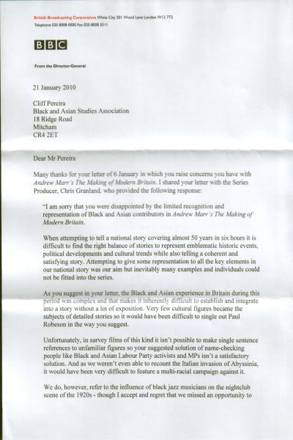
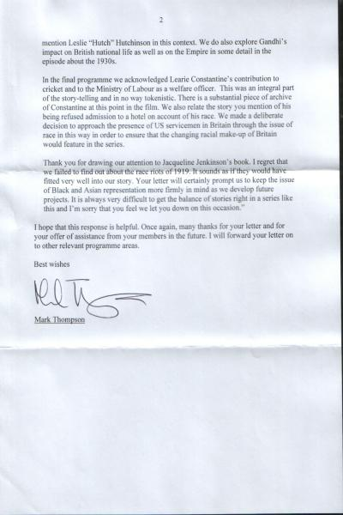

British Broadcasting Corporation White City 201 Wood Lane London W12 7TS
Telephone 020 8008 0000 Fax 020 8008 551 I

BBC

From the Director-General

21 January 2010

Cliff Pereira
Black and Asian Studies Association
18 Ridge Road
Mitcham
CR4 2ET

Dear Mr Pereira

Many thanks for your letter of 6 January in which you raise concerns you have with Andrew Marr's The Making of Modern Britain. I shared your letter with the Series Producer. Chris Granland, who provided the following response:

"I am sorry that you were disappointed by the limited recognition and representation of Black and Asian contributors in Andrew Marr's The Making of Modern Britain.

When attempting to tell a national story covering almost 50 years in six hours it is difficult to find the right balance of stories to represent emblematic historic events, political developments and cultural trends while also telling a coherent and satisfying story. Attempting to give some representation to all the key elements in our national story was our aim but inevitably many examples and individuals could not be fitted into the series.

As you suggest in your letter, the Black and Asian experience in Britain during this period was complex and that makes it inherently difficult to establish and integrate into a story without a lot of exposition. Very few cultural figures became the subjects of detailed stories so it would have been difficult to single out Paul Robeson in the way you suggest.

Unfortunately, in survey films of this kind it isn't possible to make single sentence references to unfamiliar figures so your suggested solution of name- checking people like Black and Asian Labour Party activists and MPs isn't a satisfactory solution. And as we weren't even able to recount the Italian invasion of Abyssinia, it would have been very difficult to feature a multi- racial campaign against it.

We do, however, refer to the influence of black jazz musicians on the nightclub scene of the 1920s - though I accept and regret that we missed an opportunity to mention Leslie "Hutch" Hutchinson in this context. We do also explore Gandhi's impact on British national life as well as on the Empire in some detail in the episode about the 1930s.

In the final programme we acknowledged Learie Constantine's contribution to cricket and to the Ministry of Labour as a welfare officer. This was an integral part of the story-telling and in no way tokenistic. There is a substantial piece of archive of Constantine at this point in the film. We also relate the story you mention of his being refused admission to a hotel on account of his race. We made a deliberate decision to approach the presence of US servicemen in Britain through the issue of race in this way in order to ensure that the changing make-up of Britain would feature in the series.

Thank you for drawing our attention to Jacqueline Jenkinson's book. 1 regret that we failed to find out about the race riots of 1919. It sounds as if they would have fitted very well into our story. Your letter will certainly prompt us to keep the issue of Black and Asian representation more firmly in mind as we develop future projects. It is always very difficult to get the balance of stories right in a series like this and I'm sorry that you feel we let you down on this occasion.”

I hope that this response is helpful. Once again, many thanks for your letter and for
your offer of assistance from \our members in the future. I will forward your letter on
to other relevant programme areas.

Best wishes
Mark Thompson

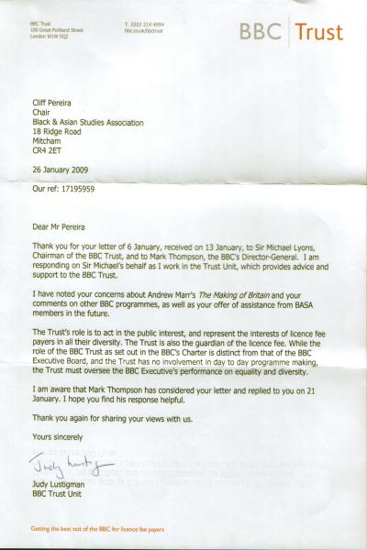

BBC Trust

Cliff Pereira
Chair
Black & Asian Studies Association -
18 Ridge Road
Mitcham
CR42ET

26 January 2009
Our ref: 17195959

Dear Mr Pereira
Thank you for your letter of 6 January, received on 13 January, to Sir Michael Lyons,
Chairman of the BBC Trust, and to Mark Thompson, the BBC's Director-General. I am
responding on Sir Michael's behalf as I work in the Trust Unit, which provides advice and
support to the BBC Trust.
I have noted your concerns about Andrew Marr's The Making of Britain and your
comments on other BBC programmes, as well as your offer of assistance from BASA
members in the future.
The Trust's role is to act in the public interest, and represent the interests of licence fee
payers in all their diversity. The Trust is also the guardian of the licence fee. While the
role of the BBC Trust as set out in the BBC's Charter is distinct from that of the BBC
Executive Board, and the Trust has no involvement in day to day programme making,
the Trust must oversee the BBC Executive's performance on equality and diversity.
I am aware that Mark Thompson has considered your letter and replied to you on 21
January. I hope you find his response helpful.

Thank you again for sharing your views with us.
Yours sincerely
Judy Lustigman
BBC Trust Unit

