BASA MEMBERS PUBLICATIONS

This page details publications written and/or published by BASA members on Britian's Black and Asian history.

STEPHEN BOURNE

See his website for details about Stephen's work on Black actors, singers and entertainers, Black history in Southwark, Esther Bruce, and Black people in the Second World War: www.

CAZ BRESSEY

'It’s only political correctness' in Claire Dwyer and Caroline Bressey (eds.) New Geographies of Race and Racism in the British Isles. Ashgate

'Victorian Photography and the Mapping of the Black Presence' in, Jan Marsh (ed.) Black Victorians: Black People in British Art, 1800 – 1900. Lund Humphries.

'Women Travellers to Britain' in Dea Birkett, Off the Beaten Track: Three Centuries of Women Travellers. National Portrait Gallery.

KATHY CHATER

Untold Histories. Black people in England and Wales
during the period of the British Slave trade, c. 1660-1807. Manchester University Press. 2009.

SEAN CREIGHTON

See his website for details inc. John Archer and Paul Robeson, slavery and abolition in the North East, Black people in the North East, and his publishing imprint titles Mother Seacole (short story) and Bill Miller: www.seancreighton.com

MARTIN HOYLES

Remember Me: Achievements of Mixed-Race People, Past & Present (with Asher Hoyles) (Hansib 1999).

Moving Voices: Black Performance Poetry (with Asher Hoyles) (Hansib 2002).

The Axe Laid to the Root: The Story of Robert Wedderburn (Hansib 2004).

Dyslexia from a Cultural Perspective (with Asher Hoyles) (Hansib 2007).

Ira Aldridge: Celebrated 19th Century Actor (Hansib 2008).

DAVID KILLINGRAY

Africans in Britain, editor (London: Frank Cass. 1994).

'Tracing peoples of African origin and descent in Victorian Kent’, in Gretchen Holbrook Gerzina, Black
Victorians/Black Victoriana (London: Rutgers U.P. 2003).

“To do something for the race”: Harold Moody and the League of Coloured Peoples’, in Bill Schwarz, ed., West Indian Intellectuals in Britain (Manchester UP. 2003).

The Black Atlantic missionary movement and Africa 1780s-1920s’, Journal of Religion in Africa, 33, 1 (2003).
'Black Baptists in Britain 1640-1950', Baptist Quarterly 40 (2003).

‘Harold Moody’, in Oxford Dictionary of National Biography (Oxford: Oxford, U.P. 2004).

‘“All conditions of life and labour”: the presence of Black people in Essex before 1950’, Essex Archaeology and History 35 (2004).

‘Kent and the abolition of the slave trade: a county study, 1760s-1807’, Archaeologia Cantiana CXVIII (2007)

‘An African hermeneutic: Quobna Ottobah Cugoano and slavery 1787’, Anvil. An Anglican evangelical journal for theology and mission, 24, 2 (2007).

Black Voices: the shaping of our Christian experiences [with Joel Edwards] (Nottingham: IVP, 2007).

‘Amgoza LoBagola’, and ‘Felix Hercules’, in H. Gates & Higginbotham, eds, African-American Dictionary of Biography (New York: OUP. 2008).
‘Black evangelicals in darkest Britain, 1780s-1930s’ in Mark Smith, ed., Evangelicalism past, present and future: Vol. II History and sociology (Carlisle: Paternoster Press, 2008).

'A good West Indian, a good African, and, in short, a good Britisher': Black and British in a colour-conscious Empire, 1760-1950’, in Robert Holland and Sarah Stockwell, eds, Ambiguities of Empire (London: Routledge, 2009) [also in Journal of Imperial and Commonweatth History, 36, 3 (2008).

'Rights, land, and labour: Black British critics of South African policies before 1948', Journal of Southern African Studies 35, 2 (2009).

''Military campaigns in Africa during the First World War', in John Horne, ed., The Blackwell Companion to the First World War (Oxford. 2009).

Fighting for Britain: African Soldiers in the Second World War (Oxford, 2009).

Entries in the Oxford Dictionary of National Biography: 'Oliver Lyseight'; 'The Pan-African conference 1900'.

DAN LYNDON

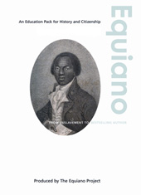

Equiano Education Pack published by Birmingham Museum and Galleries, 2007, available for £10 from http://www.equiano.org/schools.html (Jpeg attached). The Equiano Education pack is written for KS3 students to accompany the exhibition hosted by the Equiano Society and Birmingham Museum and Galleries in 2007/8. The pack uses extracts from Equiano's 'Interesting Narrative' to explore the different aspects of his life; abolitionist, activist, explorer, merchant and writer. The pack contains a wide range of activities using active learning techniques, thinking skills and innovative uses of ICT in the classroom.
Walter Tull: Sport, War & Challenging Adversity. Key Stage 2/3 published by Northamptonshire Black History Association, 2007, available for £20 from http://www.northants-black-history.org.uk/publications.asp
The Walter Tull education pack was written using archive material collected by Northamptonshire Black History Association. The pack is aimed at KS3 students and uses a variety of enquiry based activities including extended writing and film making. The material was also shown on Teachers TV in two films which can be watched at http://www.teachers.tv/video/26626 and http://www.teachers.tv/video/26634

MARIKA SHERWOOD

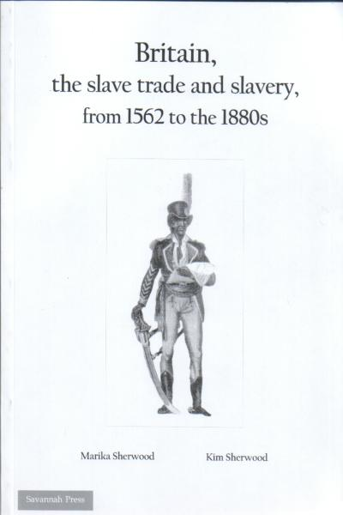
Britain, the slave trade and slavery, from 1562 to the 1880s, (with Kim Sherwood), Savannah Press 2007. ISBN 0951972057. £5 inc p&p (UK). Savannah Press, 13 Church Road, Oare, Kent, ME13 OQA. marika.sherwood@sas.ac.uk
This booklet outlines the early forms of slavery, beginning with the enslavement of the Britons by the Romans. It then describes West Africa, its culture and kingdoms when the Europeans first arrived, before going onto to look at the British trade in enslaved Africans. With much campaigning by Blacks as well as Whites, in 1807 Parliament eventually passed an Act making it illegal to trade in slaves. In 1833 another Act was passed emancipations slaves in the British possessions' in the Caribbean. But both Acts were ignored by many Britons, whose wealth derived from the trade in enslaved Africans and slavery grew hugely. The final Act abolishing slavery in British colonies was not passed until 1928. The booklet also sketches the population of African origins and descent in Britain until c. 1880, the long-term effects of slavery in Africa and the West and provides reading lists.

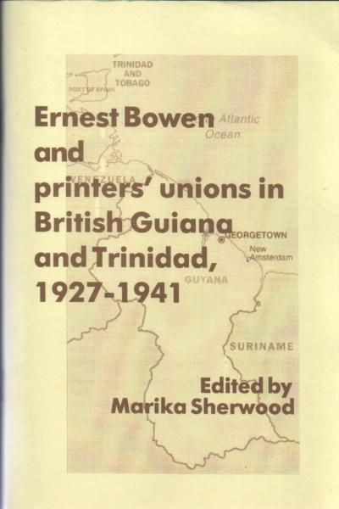
Ernest Bowen and Printers' Trade Unions in British Guiana and Trinidad, 1927-1941, London: Savannah Press, 1999. £5 available from the author. Savannah Press, 13 Church Road, Oare, Kent, ME13 OQA. marika.sherwood@sas.ac.uk
Ernest Bowen, while still an apprentice printer in Georgetown, British Guiana, participated in what was probably the first-ever-walk-out by printers. As a consequence he was unable to obtain further work in the trade and emigrated to Trinidad. There he became one of the founders of the Printers Industrial Union. In 1939 the Union called a strike and Ernest Bowen was once again barred from his trade. He was eventually employed by the US military authorities, then building their bases in Trinidad. Continuing his trade union activism – both with the United and the Federated Workers Trade Union - led to his further victimization. Mr Bowen had to leave Trinidad and after working as a merchant seaman during the war settled in Britain. This booklet is the edited transcript of hours of interview tapes with Mr Bowen.
The 1945 Pan-African Congress Revisited (with Hakim Adi). New Beacon, London 1995. £10 from the author marika.sherwood@sas.ac.uk
The 5th Pan-African Congress held in 1945, was a major event of the 20th Century. Just over a decade later, Ghana, formerly the Gold Cast, became independent in 1957. India had already been independent for a decade, since 1947. George Padmore and Kwame Nkrumah were central to this achievement, and with their organisation of the All Africa Peoples Conference in 1958, the movement for Independence in Africa moved forward in open defiance and contest with the old colonial European empires. The authors provide information and analysis about the background and substance of that historic moment. They also throw important light on the Black, Caribbean, African and Asian anti-colonial movement in British in 1945, and the demand for change in Britain itself.
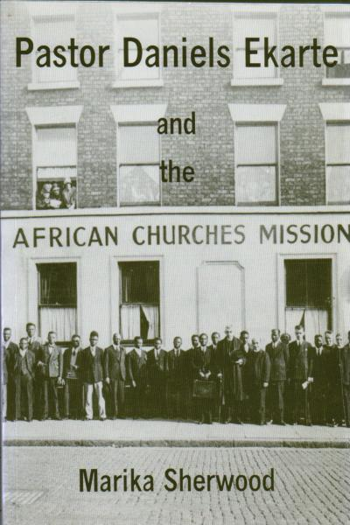
Pastor Daniels Ekarte and the African Churches Mission, Savannah Press, London 1994. £6 . Savannah Press, 13 Church Road, Oare, Kent, ME13 OQA. marika.sherwood@sas.ac.uk
Daniels Ekarte, a mission-trained young man from Calabar, Eastern Nigeria, started the African Churches Mission in Liverpool in 1931. The Mission rapidly became a social centre catering to the multifarious needs of the depression-hit community around Hill Street, Toxteth. Pastor Daniels also helped the African seamen fight for equal wages and provided a home for some of the children disowned by their mothers in the aftermath of World War II. That he did not succeed in his long-term aims of providing better educational facilities for Black youngsters, a permanent home for the abandoned children, or a better equipped social centre is due to the distrust by the White establishment of an African who believed in racial equality, self-help and who openly castigated those responsible for the rape of Africa.
Other publications
Entry on Dusé Mohamed Ali, New Dictionary of National Biography, 2009
‘Have we progressed since the Lawrence Enquiry?’, summer issue, Race Equality Teaching, 27/3 2009
‘A tale of two Ghanas’, New African, June 2009,
‘George Padmore and Kwame Nkrumah: a tentative outline of their relationship’ in Fitzroy Baptiste & Rupert Lewis (eds), George Padmore: Pan-African Revolutionary, Ian Randle Publications, 2009
‘An introduction to the Black population, racism and Black organisations in the UK in the early 20th century’ in Reappraising the Social Sciences and Humanities from African Perspectives, Sub Saharan Press, Accra Ghana, 2009
‘Miseducation and Racism’, Ethnicity and Race in a Changing World: A Review Journal, Feb. 2009 (also on www.manchesteruniversitypress.co.uk)
‘Misinformation: additional information on the MOD’s We Were There exhibition, Kent County Council, 2008
‘Africa’s history’ (comprising six articles, www.revealinghistories.org.uk (June 2008)
‘Black School Teachers in Britain in the Eighteenth and Nineteenth Centuries’, History of Education Researcher, No. 81, May 2008
So which of these ancestries do you claim when you say that you are ‘British’? www.WDWTWA.org.uk
‘Britain, the trade in enslaved Africans and slavery, www.setallfree.net/downloads/act_2007_Issue_16_%
‘The inaugural Marika Sherwood Lecture, 22 November 2007’, www.setallfree.net
‘The British illegal slave trade 1808 – 1830’, British Journal for Eighteenth-Century Studies, 31/2, 2008
‘Krishna Menon, Parliamentary Labour Party Candidate for Dundee 1939-1940’, Scottish Labour History, vol.42, 2007
‘Teaching Black history: the struggle continues’, www.irr.org.uk/2007/december/ha000008.html (November 2007)
(with Kim Sherwood), Britain, the slave trade and slavery, from 1562 to the 1880s, Savannah Press 2007
‘Atlantic slave trade and slavery up to and beyond 1807/1833’, Slavery, Abolition & Social Justice 1490 – 2007, www.slavery.amdigital.co.uk (September 2007)
‘Manchester, Liverpool and Slavery’, North West Labour History Jnl., 32 September 2007
‘After Abolition’, esi, Summer 2007
‘Britain, slavery and the trade in enslaved Africans’, www.history.ac.uk/ihr/Focus (June, 2007)
‘”There is so much more to the history of Black peoples than slavery….”’, Race Equality Teaching, 25/2, 2007
‘Post-1807 Act’, Socialist Worker, 24 March 2007
’Slaves and slavery, 1807 - 2007’, www.opendemocracy.net (2007)
‘The Nefarious Trade’, History Today, March 2007
After Abolition, IB Tauris, 2007
Entries on William G. Allen and R.R. Madden in The Encyclopedia of Emancipation and Abolition in the Trans-Atlantic World, (NY: ME Sharpe, 2007)
‘The African Diaspora in Europe’, Encyclopaedia of the World’s Minorities, Routledge 2006
Special issue: Claudia Jones, BASA Newsletter #44, January 2006
‘Introduction’ to Shiraz Durrani , Never be silent: publishing and imperialism in Kenya, 1884-1963, Vita Books (London) & Mau Mau Research Centre (N.Y.), 2006
(with Kathy Chater). ‘The Pigou Family Across Three Continents’, Proceedings of the Huguenot Society, 28/3, 2005
‘In this curriculum I don’t exist’, www.history.ac.uk/education
‘Forgotten history’, Museums Journal l, March 2005
‘Kent in the Empire and the Empire in Kent’, www.hereshistorykent.org.uk
Entries on William Davidson; Henry Sylvester Williams; Claudia Jones; Daniels Ekarte; Ras T. Makonnen; Nathaniel Fadipe and Robert Broadhurst in the New Dictionary of National Biography (OUP, 2004)
‘Lascar Struggles against discrimination in Britain 1923-1945: the work of N.J. Upadhyaya and Surat Alley’, The Mariner’s Mirror, 90/4, 2004
Britain’s Historic Black Population, Kent County Council, 2004
‘Britain, the slave trade and slavery, 1808 – 1843’, Race & Class 46/2, October-December 2004
‘Racism in Education?’, race equality reaching, 22/3 summer 2004
‘Riots, lynchings, fascists and immigrants: what’s changed? Searchlight, October 2003
‘Lascars in Glasgow and the West of Scotland during World War II’, Scottish Labour History Journal, vol. 38, 2003
(with Hakim Adi) Pan-African History: political figures from Africa and the diaspora since 1787, Routledge, 2003
‘Black People in Tudor England’, History Today, October 2003
'White Myths, Black Omissions: the historical origins of racism in Britain’, International Journal of Historical Teaching, Learning and Research, 3/1, January 2003
‘Malcolm X in Manchester, 1964’ North West History Journal , 27, 2002
'Race, Empire and Education: teaching racism', Race & Class 42/3 2001
‘Colonies, Colonials and World War Two’, www.bbc.co.uk/history/war
Claudia Jones: a life in exile, Lawrence & Wishart, 2000
'Education and the Lawrence Inquiry', Multicultural Teaching, 18/2 2000
'Lynching in Britain', History Today, March 1999
'Engendering racism: history and history teachers in English schools', Research in African Literatures, 30/1, Feb. 1999
(with Martin Spafford), Whose Freedom were Africans, Caribbeans and Indians fighting for in World War II?', Savannah Press/BASA, 1999
'Perfidious Albion: Britain, the USA and slavery in the 1840s and 1860s', Contributions to Black Studies, 13/14 1995/6 (published 1999)
'Sins of omission and commission: history in English schools and struggles for change', Multicultural Teaching, Spring 1998
'Jamaicans and Barbadians in the Province of Freedom: Sierra Leone 1802-1841', Caribbean Studies, 13/2-3, 1998
'Blacks in the Gordon Riots', History Today, December 1997
'Elder Dempster and West Africa 1891 - 1940: the genesis of underdevelopment', International Journal of African Historical Studies, 30/3, 1997
'Multiethnic history: The Picts, Greeks and Romans; The Tudors and Victorian Britain; Britain 1750-1900; Colonies, Colonials and World War II; World War II and anti-imperialist struggles' - a series in Teaching History (April 1997 - February 1998)
''India at the Founding of the United Nations', International Studies (India), 33/4, 1996
Kwame Nkrumah: the Years Abroad 1935-1947, Freedom Publications, Ghana, 1996
'The Dangers of Ethnocentrism', Teaching History, January 1996
'"There is no new deal for the blackman in San Francisco": African attempts to influence the founding conference of the United Nations April - July 1945', International Jnl. of African Historical Studies, 29/1, 1996
'The UN: Caribbean and African-American attempts to influence the founding conference in San Francisco, 1945', Journal of Caribbean History, 29/1, 1996
'"Diplomatic Platitudes": the Atlantic Charter, the United Nations and colonial independence', Immigrants and Minorities, September 1996
'The Comintern, the CPGB, Colonies and Black Britons 1920 - 1938', Science & Society, Spring, 1996
Manchester and the 1945 Pan-African Congress, Savannah Press, London 1995
‘The Colonies and World War II', Black Cultural Archives Newsletter, 2, July 1995
'Strikes! African Seamen, Elder Dempster and the Government, 1940-1942’, Immigrants & Minorities, July 1994
'SOS: Is Anybody Listening?', Teaching History, June 1994
‘Nkrumah: the Student: Years in London 1945-1947’, Immigrants & Minorities, September, 1993
(with Bob Rees), Black Peoples of the Americas, Heinemann, 1992
Black Peoples in the Americas - a handbook for teachers, Savannah Press, London 1992
‘Walter White and the British: a lost opportunity’, Contributions to Black Studies, Nos. 9/10, 1990-1992
‘Quakers and Colonials 1930-1950’, Immigrants & Minorities, July 1991
‘Racism and Resistance: Cardiff in the 1930s and ‘40s’, Llafur (Welsh Labour History Journal), September 1991
‘The Hungarian Speech Community’, in S. Alladina & V. Edwards, Multilingualism in the British Isles, Longman, 1991
‘Race, Nationality and Employment among Lascar Seamen 1660 to 1945', New Community, January 1991
‘Ticket of Leave’, History Today, August 1990
Women Under the Sun (African Women in Politics and Production - a bibliography), IFAA, London, 1988
‘It’s Not a Question of Racism; a case study of institutional racism 1941-1943’, Immigrants & Minorities, July 1985
Many Struggles ( West Indian Workers and Service Personnel in Britain 1939-1945), Karia Press, London 1985
‘The War Against Blacks in Britain’, Freedomways, 4th Quarter 1982
The British Honduran Forestry Unit in Scotland, OC Publishers, London, 1982
Weekly articles on ‘Blacks in Britain’, The Voice, 1991-1992

